Router A configuration code
conf t

! -- 1. Fix the IT Department (Slot 2) --
interface GigabitEthernet2/0
description Gateway for IT Dept
ip address 192.168.2.1 255.255.255.0
no shutdown
exit

! -- 2. Fix the WAN Link (Built-in Port) --
interface FastEthernet0/0
description WAN Link to Branch B
ip address 10.0.0.1 255.255.255.252
no shutdown
end
write memory

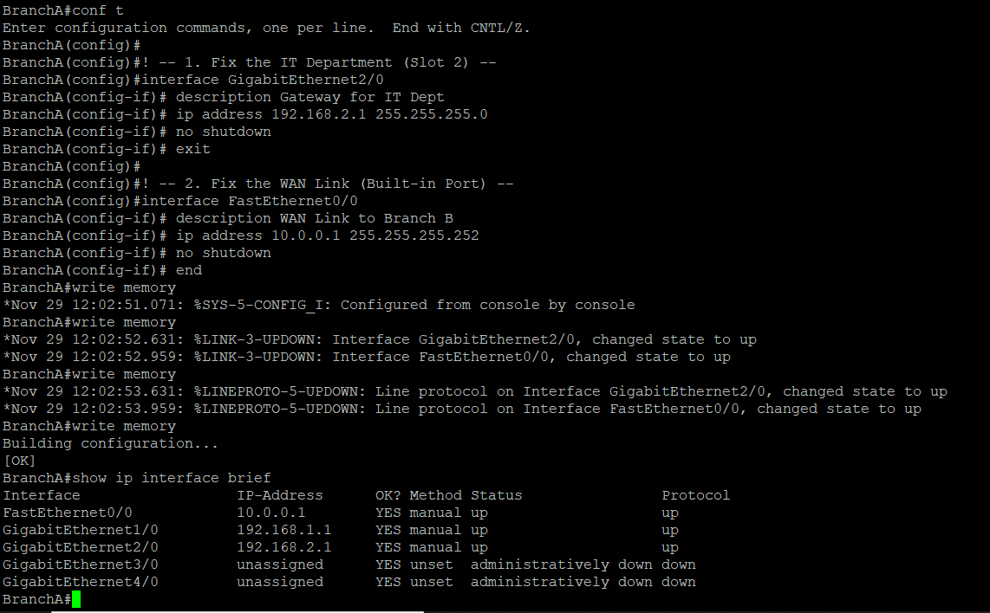

Router B Config Code
conf t

! -- 1. Configure Sales Dept (Slot 1) --
interface GigabitEthernet1/0
description Gateway for Sales Dept
ip address 192.168.3.1 255.255.255.0
no shutdown
exit

! -- 2. Configure CS Dept (Slot 2) --
interface GigabitEthernet2/0
description Gateway for CS Dept
ip address 192.168.4.1 255.255.255.0
no shutdown
exit

! -- 3. Configure WAN Link (Built-in Port) --
interface FastEthernet0/0
description WAN Link to Branch A
ip address 10.0.0.2 255.255.255.252
no shutdown
end
write memory

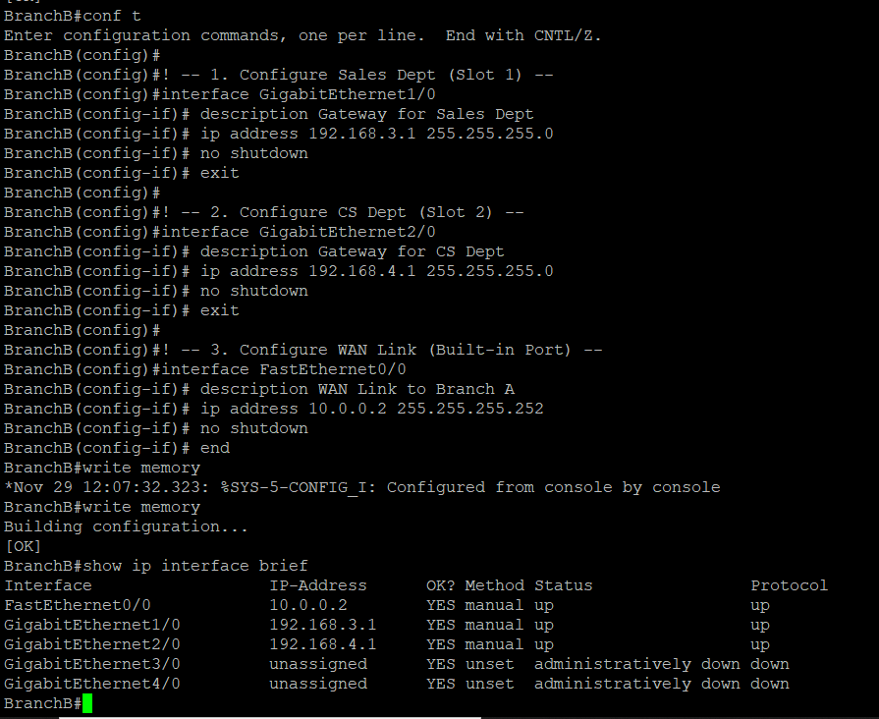

Step 3: Configure the PCs (Task 1)
Now you must assign the IPs to the PCs as per the PDF.
Open the console for each PC and type the single line command:
- HR_PC1: ip 192.168.1.2 255.255.255.0 192.168.1.1
- HR_PC2: ip 192.168.1.3 255.255.255.0 192.168.1.1
- IT_PC1: ip 192.168.2.2 255.255.255.0 192.168.2.1
- IT_PC2: ip 192.168.2.3 255.255.255.0 192.168.2.1
- Sales_PC1: ip 192.168.3.2 255.255.255.0 192.168.3.1
- Sales_PC2: ip 192.168.3.3 255.255.255.0 192.168.3.1
- CS_PC1: ip 192.168.4.2 255.255.255.0 192.168.4.1
- CS_PC2: ip 192.168.4.3 255.255.255.0 192.168.4.1

(Note: The last IP in each command is the Gateway—the Router IP we set in Step 2).

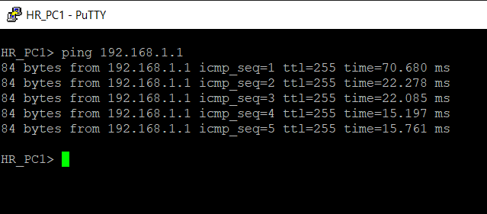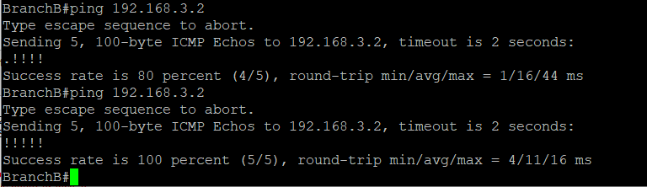

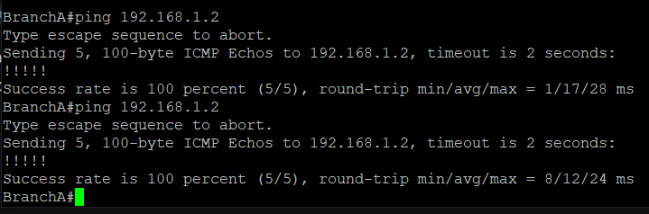

The internal network is working properly so but the whole network connection issue
When connecting to branch B sales pc get no response
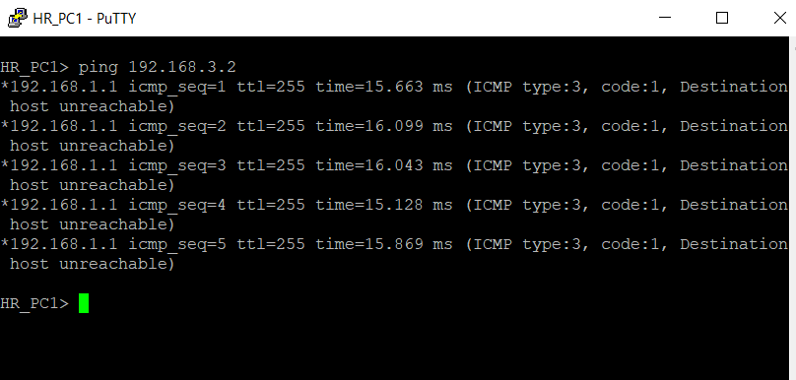

Final Step: Enable OSPF (Connecting the Branches)

Router A config
conf t
router ospf 1
! -- Advertise local networks to the world --
network 192.168.1.0 0.0.0.255 area 0
network 192.168.2.0 0.0.0.255 area 0
! -- Advertise the WAN link --
network 10.0.0.0 0.0.0.3 area 0
end
write memory

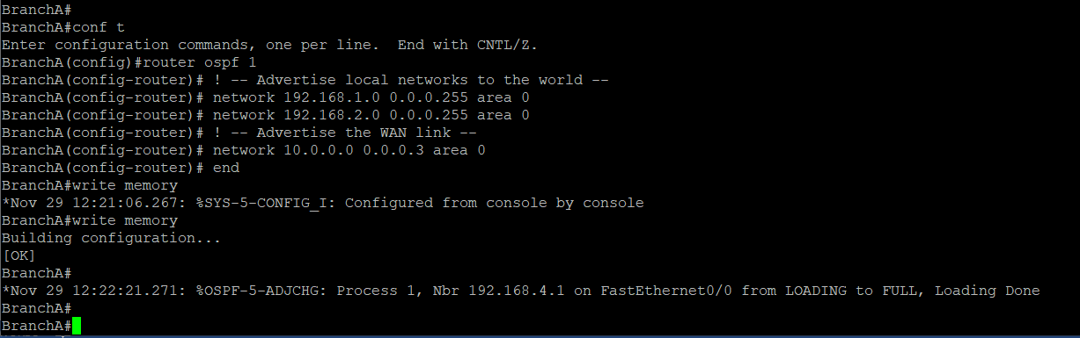
Router B config

conf t
router ospf 1
! -- Advertise local networks to the world --
network 192.168.3.0 0.0.0.255 area 0
network 192.168.4.0 0.0.0.255 area 0
! -- Advertise the WAN link --
network 10.0.0.0 0.0.0.3 area 0
end
write memory

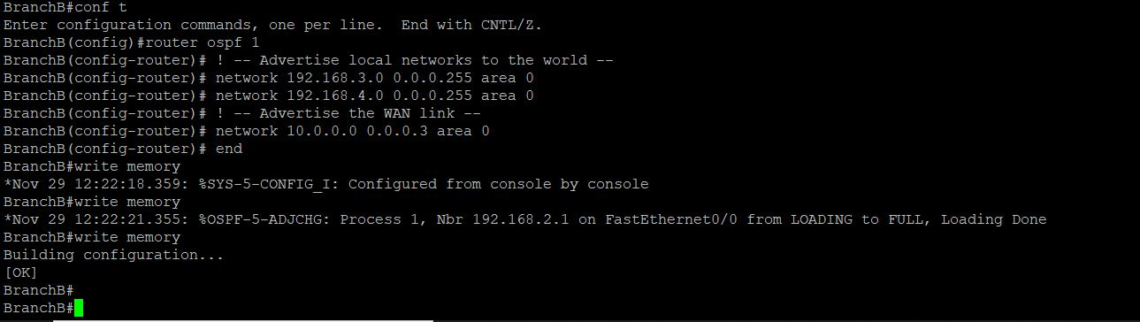

Now connecting again to branch sales pc
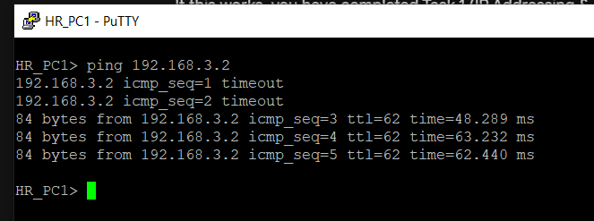

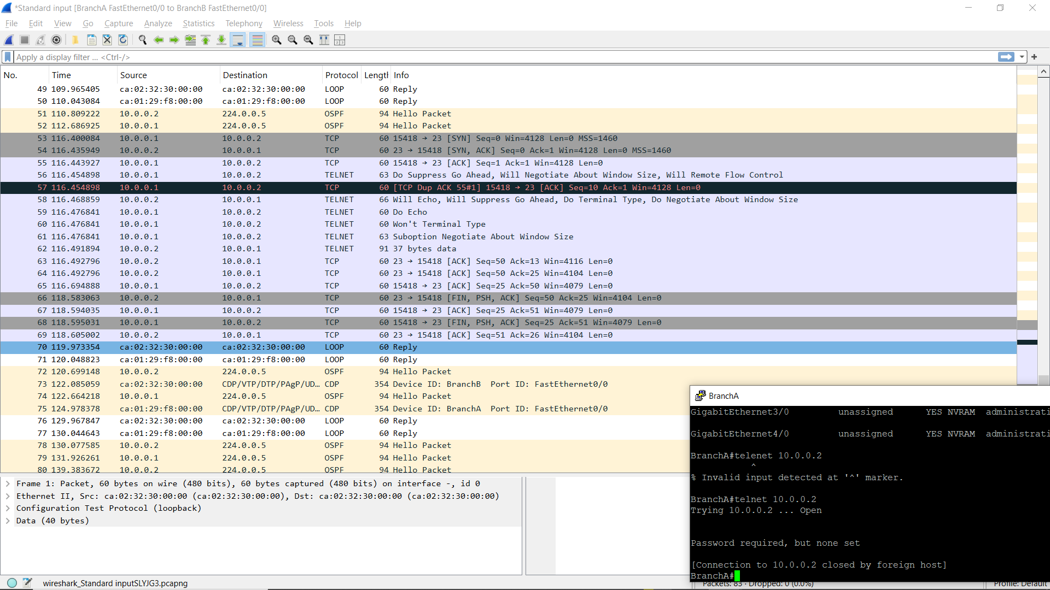

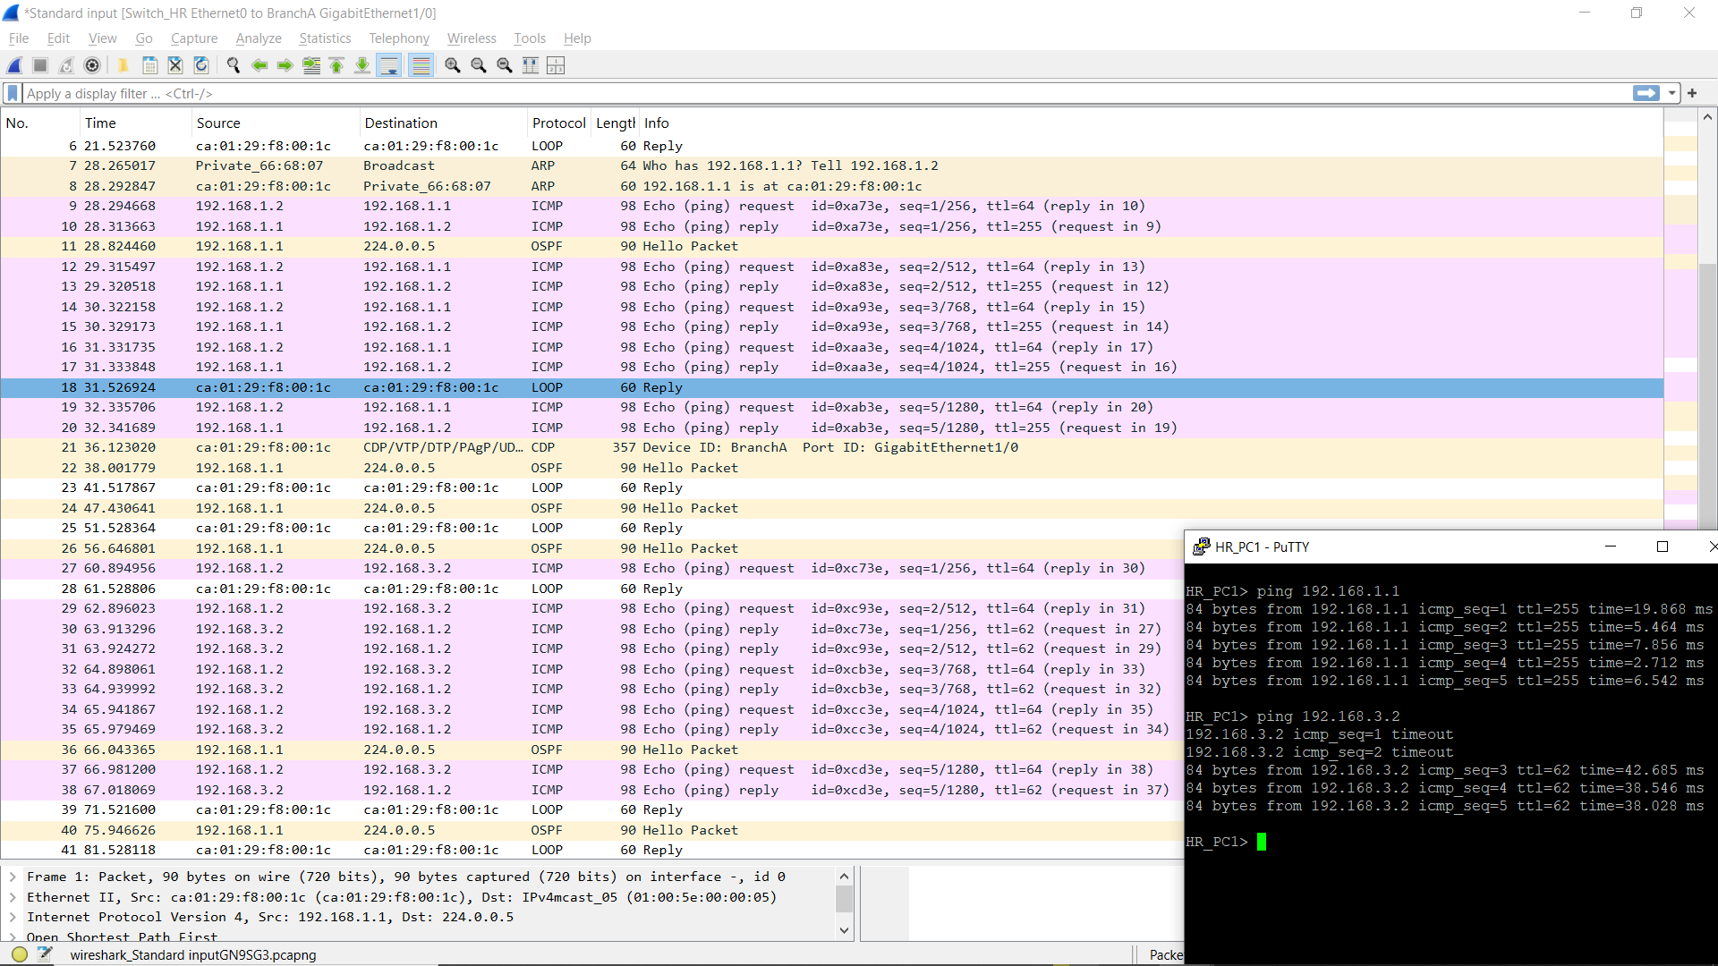

- Brancg A and Switch_HR hr_pc 1 console ping 192.168.3.2

Router A and Router B
BranchA Console telnet 10.0.0.2

Task 2: TCP/IP Traffic Simulation

Step 1: Open Wireshark Correctly (Inside GNS3)
- Go to your GNS3 Topology.
- Right-click the black line (link) connecting BranchA router and Switch_HR.
- Select Start Capture from the menu.
- A small box will appear. Click OK.
- Wait: A new Wireshark window will open automatically. The title bar will say something like "Capturing on Ethernet0...".
Step 2: Generate ICMP Traffic (Ping)
Now that the "camera is rolling," we need to make some "action" happen on the network.
- Open the console for HR_PC1.
- Type this command to ping the Sales department in the other branch: ping 192.168.3.2
- Let it run for 5 seconds (you will see the replies).
- Go to the Wireshark window. You should see lines highlighted in pink/light purple with the protocol ICMP.
- Click the Red Stop Button (top left) in Wireshark to save the capture.
Step 3: Generate TCP Traffic (The Optional Task)
The assignment asks for TCP traffic (Telnet). VPCS (the little PCs) are very basic and struggle with Telnet. The best way to show TCP traffic is to use your Routers.
- Right-click the WAN link (the wire between Router A and Router B).
- Select Start Capture -> OK.
- Open the BranchA Console.
- Type this command to try and "call" Branch B: telnet 10.0.0.2
- It might say "Connection refused" or "Open"—that is totally fine. The attempt itself creates the TCP Handshake (SYN packets) that we need to capture.
- Stop the Wireshark capture. You should see lines highlighted in green or gray with the protocol TCP.

